Homework 1 - Vector - Self Evaluation

It took me five hours to complete this homework.
The test error I’ve got was : method X in class Y can not be applied to given types. It was caused by using static keyword in my code. From this error I learn more about the static method, which is more important is that I had a deeper understanding of the Object-Oriented Design.

Static methods and variables are part of the class, not the instances of the class. A static method can access only static variables of class and invoke only static methods of the class. Usually, static methods are utility methods that we want to expose to be used by other classes without the need of creating an instance.

The object method belongs to a method of a class. Before calling it, we need to create an instance of the class and call it through the instance of the class.

Here are some screenshots of this homework.
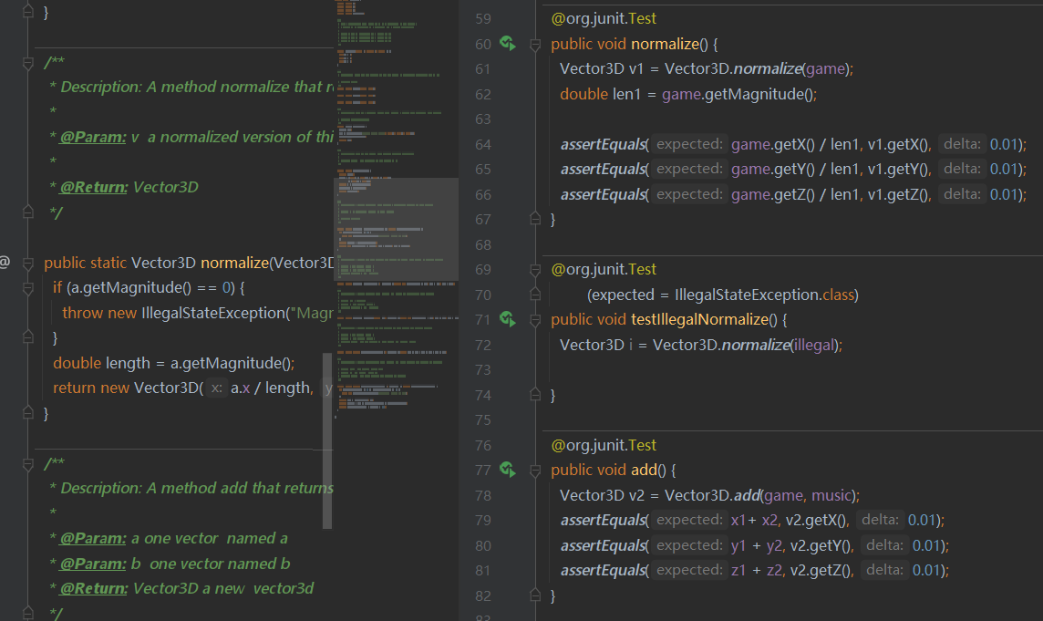
Primary code with static method

The error
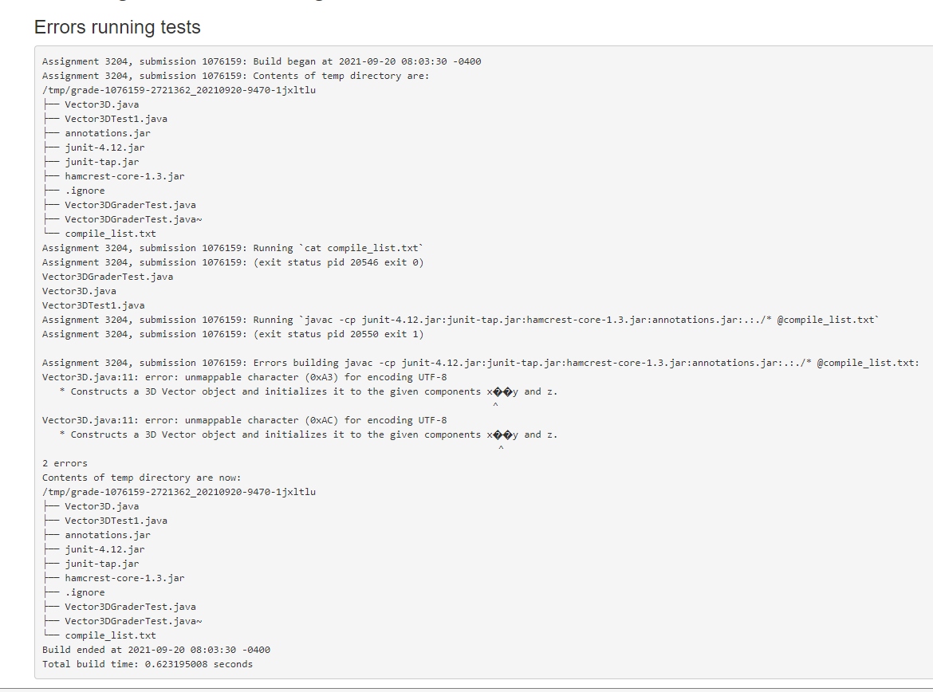

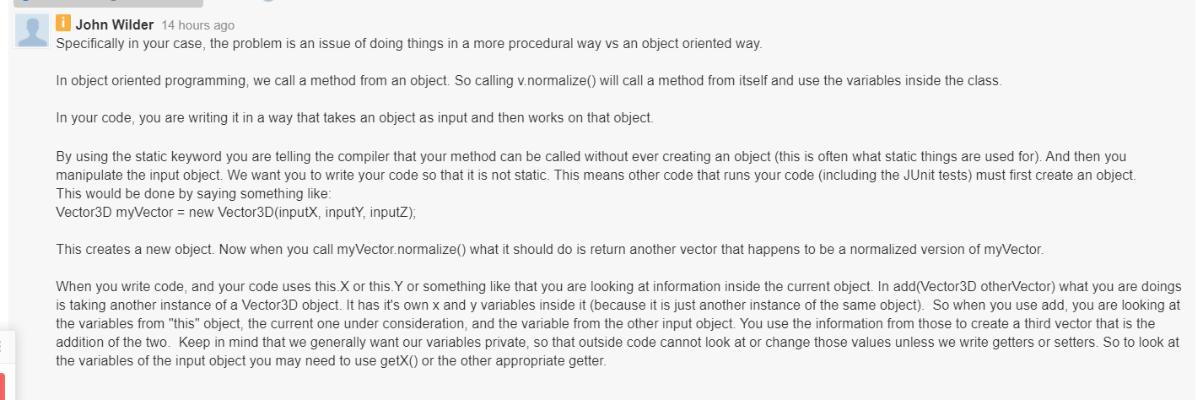
The instructor's answer targeted to above

